Comparing neighborhood of Abidjan and Dakar

Senyo Adzimah

April 13, 2021

Table des matières

1. Introduction(Business Problem) 1

2. The Data 1

2.1 Abidjan neighborhoods. 2

2.2 Dakar neighborhoods. 2

2.3 Venues data. 3

# Introduction([Business Problem](http://localhost:8888/notebooks/Downloads/capstone/capstoneProject_BattleOfNeighborhoods.ipynb#introduction))

The purpose of this project is to analyze the neighborhoods data of two western Africa cities namely Abidjan and Dakar with Data Science to see if there are any kind of similarities between them.

Abidjan is the capital city of Cote d’Ivoire (Ivory Coast) and Dakar is the capital city of Senegal. An insight of the similarities or dissimilarities can help basically tourists (to make a choice between the two cities) or those who would like to relocate in one of these cities

# The Data

In a structured format, it was difficult to find documented at one place, neighborhoods information about Abidjan and Dakar. Particularly the localization information such as Latitude and Longitude.

We proceeded from site to site in order to collect the data on the neighborhoods and put them together in csv files (Dakar_data.csv, Abidjan_data.csv).

For instance, to collect the coordinates info, we had to search on geo-localization web pages’ neighborhoods per neighborhood. This imply that scraping the web via a code couldn’t help.

## 2.1 Abidjan neighborhoods.

The data is comprised of the neighborhoods in Abidjan. In all they are thirteen (13) and below the columns description:

1. *Neighborhoods*: The name of the neighborhoods
2. *Latitude:* The latitude of the neighborhood
3. *Longitude:* The longitude of the neighborhood

|  |  |  |
| --- | --- | --- |
| Neighborhood | Latitude | Longitude |
| Abobo | 5.432887 | -4.038892 |
| Adjamé | 5.365073 | -4.023572 |
| Yopougon | 5.365073 | -4.023572 |
| Le Plateau | 5.323212 | -4.023689 |
| Attécoubé | 5.3362 | -4.0414 |
| Cocody | 5.35 | -3.9833 |
| Koumassi | 5.303 | -3.9419 |
| Marcory | 5.3027 | -3.9827 |
| Port-Bouët | 5.2773 | -3.8859 |
| Treichville | 5.2936 | -4.0083 |
| Anyama | 5.5 | -4.05 |
| Bingerville | 5.35 | -3.9 |
| Songon | 5.2917 | -4.2454 |

*Table 1 : Abidjan neighborhoods.*

## Dakar neighborhoods.

Dakar neighborhoods are in all thirteen (18) The data list the neighborhoods with:

1. *Borough:* The names of the borough
2. *Neighborhoods*: The name of the neighborhoods
3. *Latitude*: The latitude of the neighborhood
4. *Longitude:* The longitude of the neighborhood

|  |  |  |  |
| --- | --- | --- | --- |
| Borough | Neighborhood | Latitude | Longitude |
| Almadies | Mermoz-Sacré-Cœur | 14.703417 | -17.474614 |
| Almadies | Ngor | 14.744162 | -17.512056 |
| Almadies | Ouakam | 14.723712 | -17.494233 |
| Almadies | Yoff | 14.747126 | -17.490256 |
| Dakar Plateau | Dakar-Plateau | 14.67183 | -17.418832 |
| Dakar Plateau | Fann-Point E-Amitié | 14.697605 | -17.456508 |
| Dakar Plateau | Gorée | 14.66683 | -17.392332 |
| Dakar Plateau | Gueule Tapée-Fass-Colobane | 14.673452 | -17.46325 |
| Dakar Plateau | Médina | 14.6822 | -17.4494 |
| Grand Dakar | Biscuiterie | 15 | -17.4542 |
| Grand Dakar | Dieuppeul-Derklé | 14.725 | -17.4514 |
| Grand Dakar | Grand Dakar | 14.7042 | -17.4533 |
| Grand Dakar | Hann Bel-Air | 14.7103 | -17.435 |
| Grand Dakar | HLM | 14.7235 | -17.4433 |
| Grand Dakar | Sicap-Liberté | 14.7109 | -17.461 |
| Parcelles Assainies | Cambérène | 14.7708 | -17.4308 |
| Parcelles Assainies | Grand Yoff | 14.7336 | -17.4494 |
| Parcelles Assainies | Les Parcelles Assainies | 14.7569 | -17.4347 |
| Parcelles Assainies | Patte d'Oie | 14.745 | -17.4342 |

*Table 2: Dakar neighborhoods*

## Venues data.

Foursquare is a technology company that built a dataset of accurate localization data. We use its API (free) to get information about venues located in a radius of 1500 m around each neighborhoods of interest (given their latitude and longitude). Next we build a data frame out of the Json we received from the API as shown below.

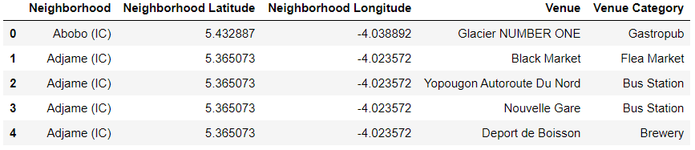

*Table 3: Foursquare venues categories(short list)*